Answer **behavioral interview questions** using the STAR method

**Activity Overview**

In this activity, you will answer two common **behavioral interview questions** using the STAR method.

As you've learned, the STAR method is a helpful strategy for answering behavioral interview questions in a clear, organized, and engaging way. STAR stands for “situation,” “task,” “action,” and “result.” In an interview, you may be asked behavioral interview questions. These types of questions require you to share a time when you were faced with a particular situation or had to practice a certain skill.

Be sure to complete this activity before moving on. The next course item will provide you with a completed exemplar to compare to your own work.

**Scenario**

Review the following information. Then complete the step-by-step instructions.

When you use the STAR method to answer behavioral interview questions during an interview, interviewers get a better sense of who you are as a candidate and why you’ve applied for the role. The STAR method can make your responses easier for them to follow by creating a logical structure to each story you share. Preparing and practicing responses using the STAR method in advance can also help you feel more confident going into an interview.

In this activity, you will prepare responses to two common behavioral interview questions. First, you will recall and record notes about experiences you’ve had in the past that demonstrate your key skills. Then, you will select two questions from a list of behavioral questions frequently asked during interviews. You will answer each of these questions using the STAR method. Finally, you have the option to practice answering these questions and others aloud in front of a mirror, friend, or family member.

**Step-By-Step Instructions**

Follow the instructions and answer the question below to complete the activity. Then, go to the next course item to compare your work to a completed exemplar.

**Step 1: Access the template**

To use the template for this course item, click the following link and select *Use Template.*

Link to template: [STAR responses worksheet](https://docs.google.com/document/d/1FWZ8bsmaz2JvzWfGNOhS8qCNZL9Y7nozekZUZ9us5CY/template/preview?usp=sharing&resourcekey=0-JK8_xEsivsJ2WSidYecHlg)

OR

If you don’t have a Google account, you can download the template directly from the following attachment.

Step 2: Identify experiences that demonstrate your skills

Research the most commonly sought skills cybersecurity analysts have by reviewing job descriptions on platforms like [Indeed](https://www.indeed.com/), [LinkedIn™ Job Search](https://www.linkedin.com/jobs/), and/or [CareerBuilder](https://www.careerbuilder.com/). Then, consider the experiences you’ve had that demonstrate those types of skills. These may be past work experiences, school projects, volunteer positions, or any other relevant activities you’ve done—even the completion of this program.

Add notes on at least three of those experiences to the **Experiences** **that demonstrate my skills** section of the STAR responses worksheet.

Step 3: Select interview questions

Step 4: Describe the situation

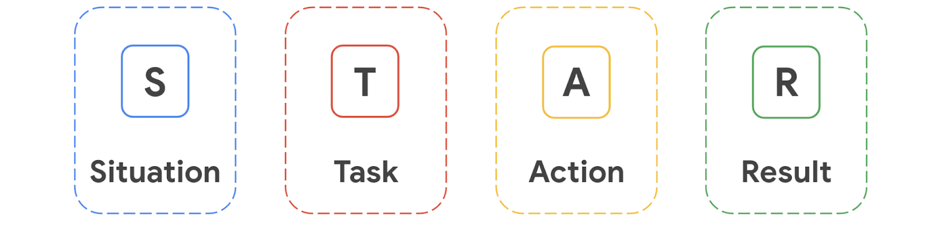

Step 5: Describe your task

Step 6: Explain the actions you took

Step 7: Share your results

Finally, it's time to share the conclusion of your story by summarizing what you achieved.

In the **Results** section of Question 1, add a short paragraph (2-4 sentences) describing the outcome of the actions you took and the impact you had. When possible, use data—such as numbers and percentages—to reinforce your response. If you’re sharing an experience that came with challenges, you may also want to share the lessons you learned.

Step 8: Answer the second question

Repeat steps 4–7 to answer **Question 2** using the STAR method.

(Optional) Step 9: Practice your responses aloud

Finally, to prepare yourself to answer these types of questions verbally, practice your answers out loud in front of a mirror or with a friend or family member. Try answering additional questions from the list of **Common Behavioral Interview Questions for Cybersecurity Analysts** in the same manner.

**Pro Tip: Save the template**

Be sure to save a blank copy of the STAR responses template you used to complete this activity. You can use it for further practice or as you prepare for professional interviews. This template will help you work through your thought processes and demonstrate your experience to potential employers.

**What to Include in Your Response**



Be sure to address the following criteria in your completed STAR responses:

* A description of three **experiences** that showcase your skills
* A selection of two **interview questions** to answer
* A description of the following as it relates to each question:
  + A **situation** you experienced (two to three sentences)
  + The **task** you were asked to complete or your responsibility in the situation (one to two sentences)
  + The **actions** you took to meet the challenge or solve the problem (two to four  sentences)

**1.**

Question 1